Joining Multiple Lin Files Roger Pfister
You have a collection of lin files and you want to quickly JOIN (merge) them into a single lin file. Possibly because you want to then process them with rotations etc using the Multi Deal Save command. See doc-collection document
Lin_Files_-_a_Starter.doc
In Windows you can use command box and the copy command to do this
and on a MAC you use a "terminal" and the cat (concatenate) command to do this.
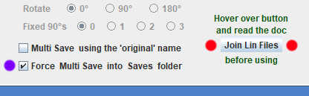
However as a convenience aaBridge comes with a built-in method to do this quickly and simply.
Lift the lower divider on aaBridge window and you will see the set of buttons shown in the diagram.
Drag-and-drop a group of lin files or a folder containing lin files onto the main aaBridge window. As normal they will show as a list in the left-hand column.
When you click the Join Lin Files button (red dots) all the Lin files in your list will be Joined (copied and merged) into a single lin file with the name
0000 0000 joined.lin
Unless you have checked Force Multi Save into Saves folder (purple dot) this file will be put in the same folder as your original lin files.
This feature will also work on the temp_MyHands, temp_Other and the Saves folder. It will not work on any internal aaBridge folders such as the Welcome folder.
Any Lin file whose name contains the word joined will be ignored and not included.
It is expected that you will then normally rename and process the newly created lin file using the Multi Deal save feature, see the document mentioned earlier.
<end document>

